1. 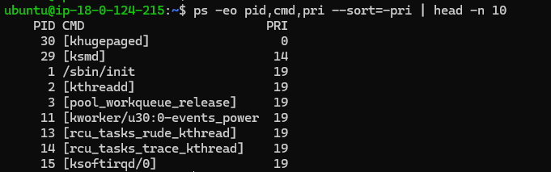List out highest priority process in the system

2) Open the terminal with 2 tabs or sessions  
    a)  run command "vmstat 1"  
    b) switch to another tab,  pause  running vmstat command for few seconds and resume it again

1. 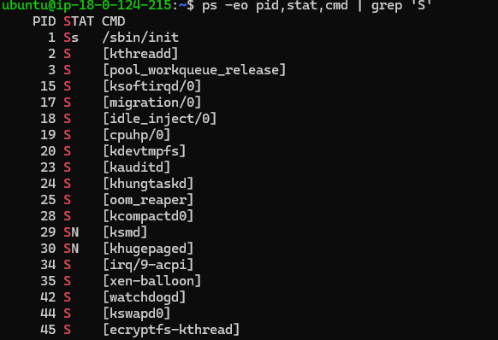Find the process which is sleeping in "wait" state.